INVESTIGATIVE RHINOLOGY COURSE
23^{-rd} of November 2018
University Hospital “Kaspela” (10^{-th} Floor, 2^{-nd} Block), Plovdiv, Bulgaria
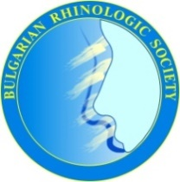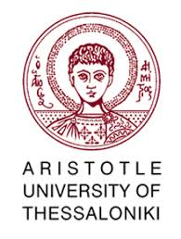
Organizing Committee:
D. Vicheva, R. Benchev, K. Dzhambazov, V. Tzvetkov, I. Doykov, T. Avramov
Co - Directors: I. Konstantinidis; E. Tsakiropoulou; A. Chatziavramidis;
Franco Frati

Dear Colleagues,
This is the 1^{-st} Bulgarian Intensive Course on Investigative Rhinology and the 2^{-nd} European Intensive Course, organized by the 2nd Academic ORL department of Aristotle University, Thessaloniki, Greece and by the Bulgarian Rhinologic Society, providing hands on experience in all the available objective measurements of nasal functions.

Scientific Programme:
11.00 – 11.05 Welcome opening D. Vicheva/ I. Konstantinidis
11.05 - 11.30 PNIF/Acoustic rhinometry/Rhinomanometry D. Vicheva/ I. Konstantinidis
11.30 – 11.45 Skin prick tests E. Tsakiropoulou
11.45 – 12.05 Sublingual Immunotherapy in Allergic Rhinitis Franco Frati
12.05 – 12.20 Olfactory disorders management I. Konstantinidis
12.20 - 12.35 Laboratory tests in Rhinology A. Chatziavramidis
12.35 - 13.30 Break
13.30 - 16.00 Hands on:
Station 1 4 phase Rhinomanometry / PNIF (group of 15 doctors - A)
Station 2 Olfactory testing (orthonasal, retronasal) (group of 15 doctors - B)
Station 3 Skin prick tests (group of 15 doctors - C)
All groups are doing rotation in each station!
19.30 Dinner in the restaurant “South Breeze” („Южен полъх“)

Registration: Free of charge (covered by BRS)
The course is under the auspices of the:
ERS; Balkan ORL Society; Bulgarian ORL-HNS Society

